# 

EE 463

STATIC POWER CONVERSION I

HARDWARE PROJECT SIMULATION REPORT

Orhun TAŞOĞLU 2094506

Mert ZEYBEK 2167682

Kutay DELİBAŞ 2093599

Submission Date: 03.12.2019

# 

# **INTRODUCTION**

This report includes details of 3 Phases 1 Company’s topology selection, computer simulation results of the topology and component selections for driving a DC Motor with either a single phase or 3 phase adjustable AC voltage input.

# **TOPOLOGY SELECTION**

Our first aim is converting AC input to DC input which can be done by either using diode switches or thyristor switches. Using thyristor switches are advantageous since controlling firing angles also enables us to control DC voltage level. Speed of the motor is proportional to DC voltage applied to armature winding and controlling its speed is our second aim. However, synchronization of gate signals might be problematic in implementation. In single phase thyristor rectifier, this problem becomes easier due to number of thyristors but ripple frequency of a single phase rectifier is 100 Hz which is one third of the 3 phase case. Lower ripple frequency means a filter with lower corner frequency needs to be used which would require higher inductance and capacitance in the filtering elements.Another problem with the single phase thyristor rectifier topology is requirement for components with higher current rating in order to transfer enough power.Cooling them would be another issue. As a result, both thyristor topologies have some disadvantages.

On the other hand, using a diode rectifier topology does not have a problem like synchronization of the gate signals and 3 phase input can be used. The problem with the diode rectifier is we cannot control output voltage. Hence, we cannot control the speed as well. In order to achieve both our goals with diode topology, we need another stage to control DC output. Since our voltage output from previous stage is high enough and we need to lower it, our DC-DC converter topology will be buck converter. Buck converter is not hard to implement but requires a PWM signal to control on and off state of the transistor.For the buck converter, there are 2 main considerations while designing. Firstly, for the filtering elements, L and C value will be chosen such that they are high enough to make output ripple small. But they shouldn’t be the largest possible values, since they become a lot more expensive and cause more loss.Effect of corner frequency of the filter and switching frequency can be seen in equation (1) where D is the duty cycle, fc is the corner frequency, fs is the switching frequency, while ΔVo and Vo are output voltage ripple and average output voltage. In this equation it can be seen that voltage ripple is related with square of ratio of two frequencies.

$ΔVo/Vo=π^{2} /2 * (1-D) * (fc/fs)^{2}$ (1)

For example, assuming 10kHz switching operation, corner frequency should be at most 1kHz in order to see 1% ripple at the output. Various L and C values were chosen and simulated to see their effect.

Second one is the switching element, which can either be a mosfet or IGBT. We decided to use low side IGBT buck converter topology since it is easier to control because it is ground referenced. Although output cannot be ground referenced in this case, it will not cause a problem to us while driving a motor. To conclude, 3-phase diode rectifier and buck converter will be our topology to implement.

# **SIMULATION RESULTS**

Effect of rectifier output capacitance value on rectifier output voltage can be seen in Figure 1 through 4.

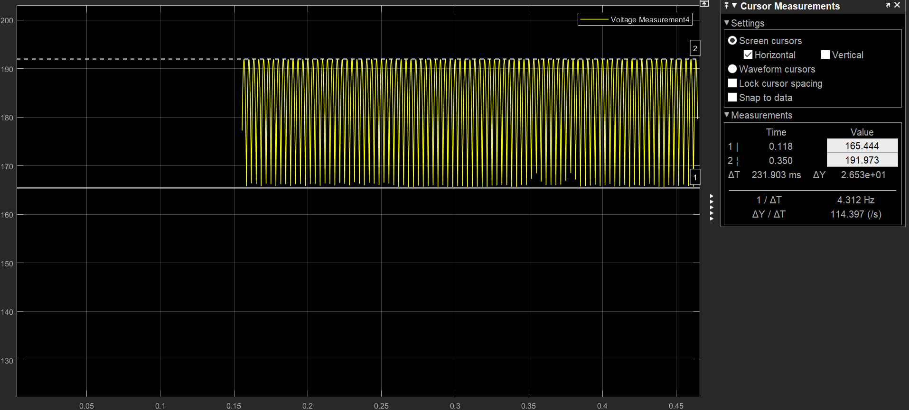

Figure 1: 470 uF capacitor with 26V peak to peak ripple.

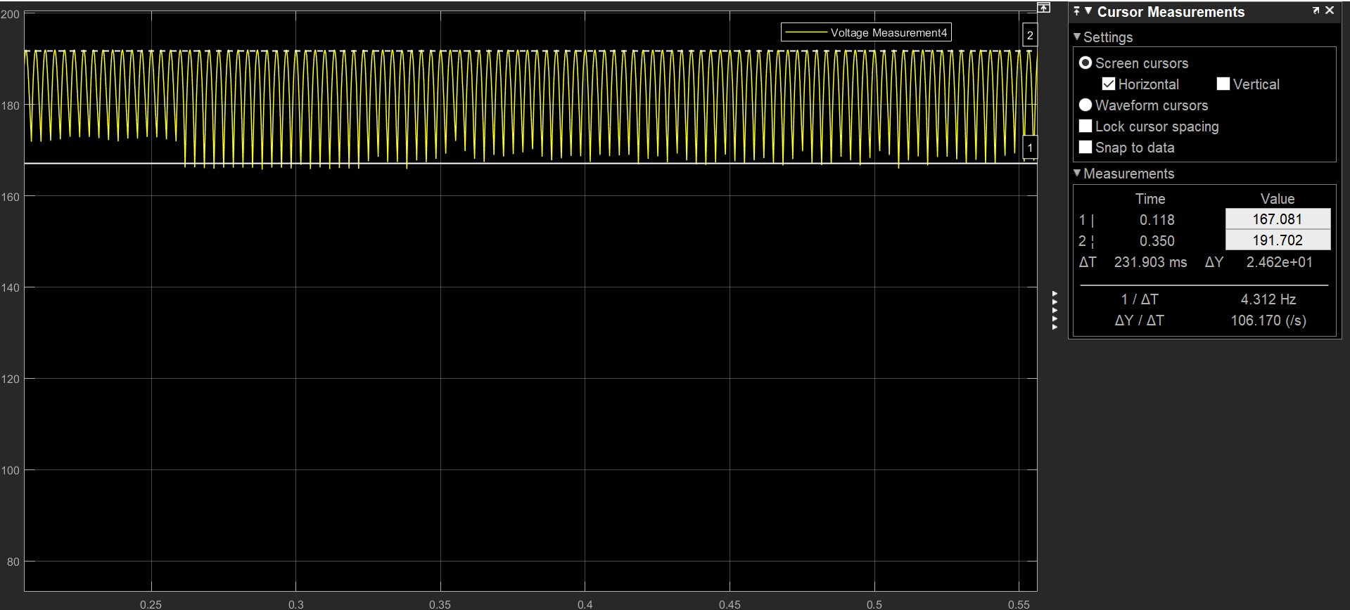

Figure 1: 1000 uF capacitor with 24V peak to peak ripple.

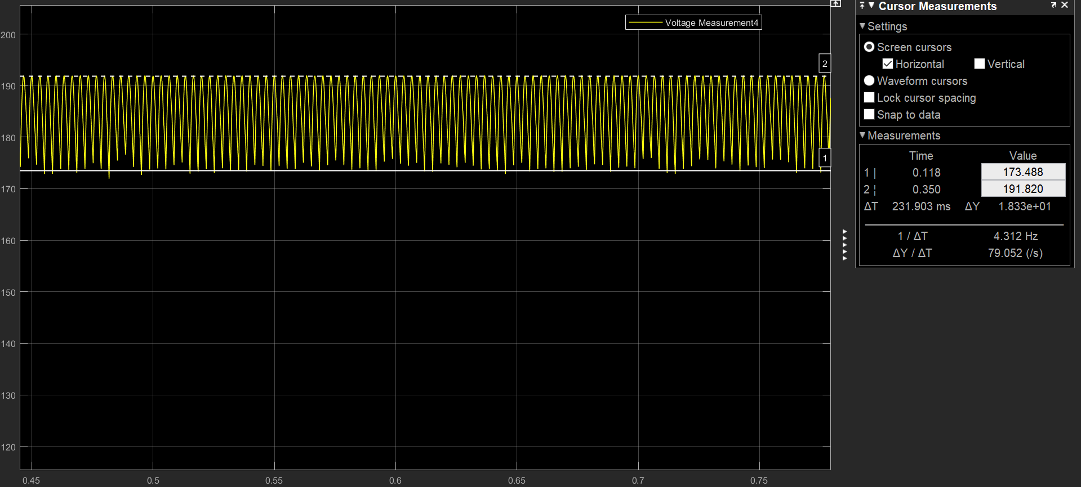

Figure 1: 2000 uF capacitor with 18V peak to peak ripple.

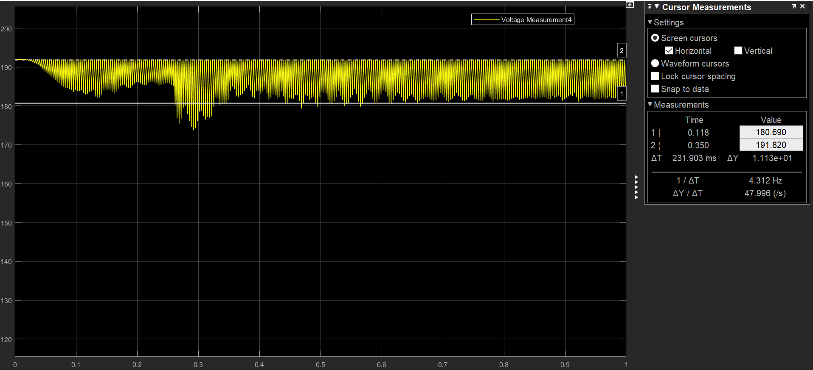

Figure 1: 4700 uF capacitor with 11V peak to peak ripple.